**Employee Data Analysis**

1,Write a query to create an employee table with the fields employee id, first name, last name, job id, salary, manager id, and department id.

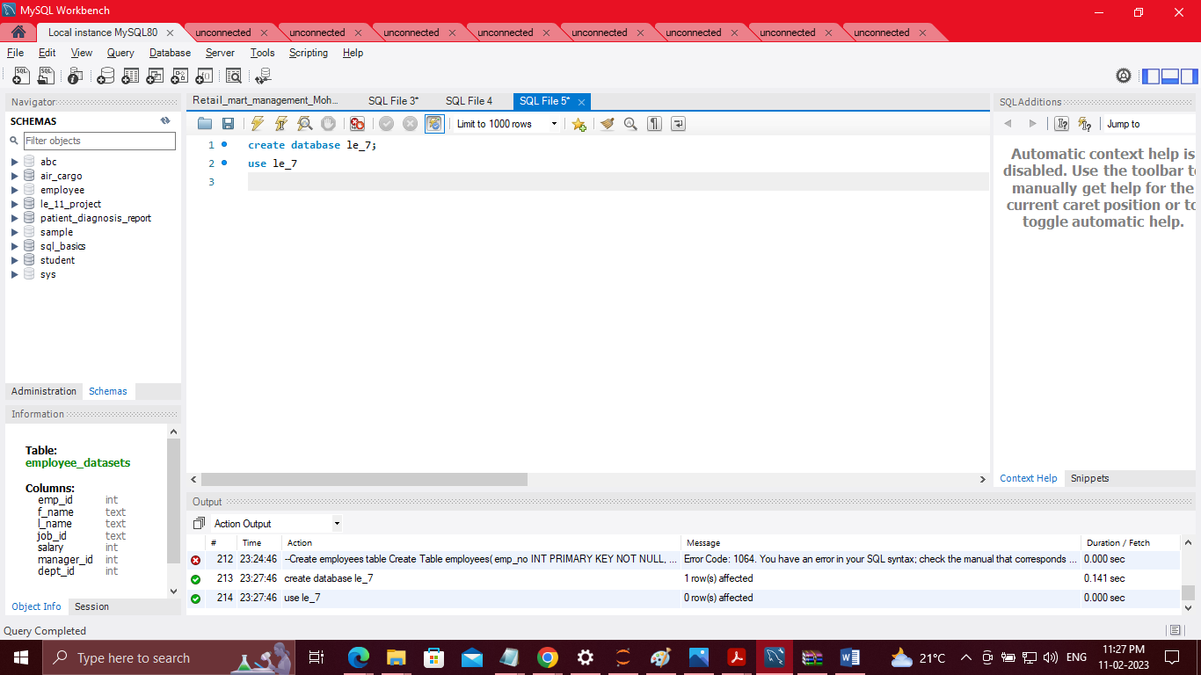  
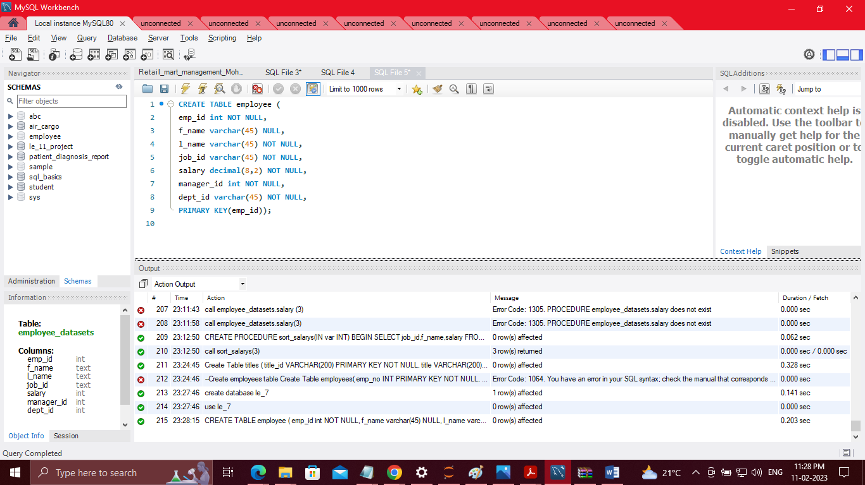

2, Write a query to insert values into the employee table

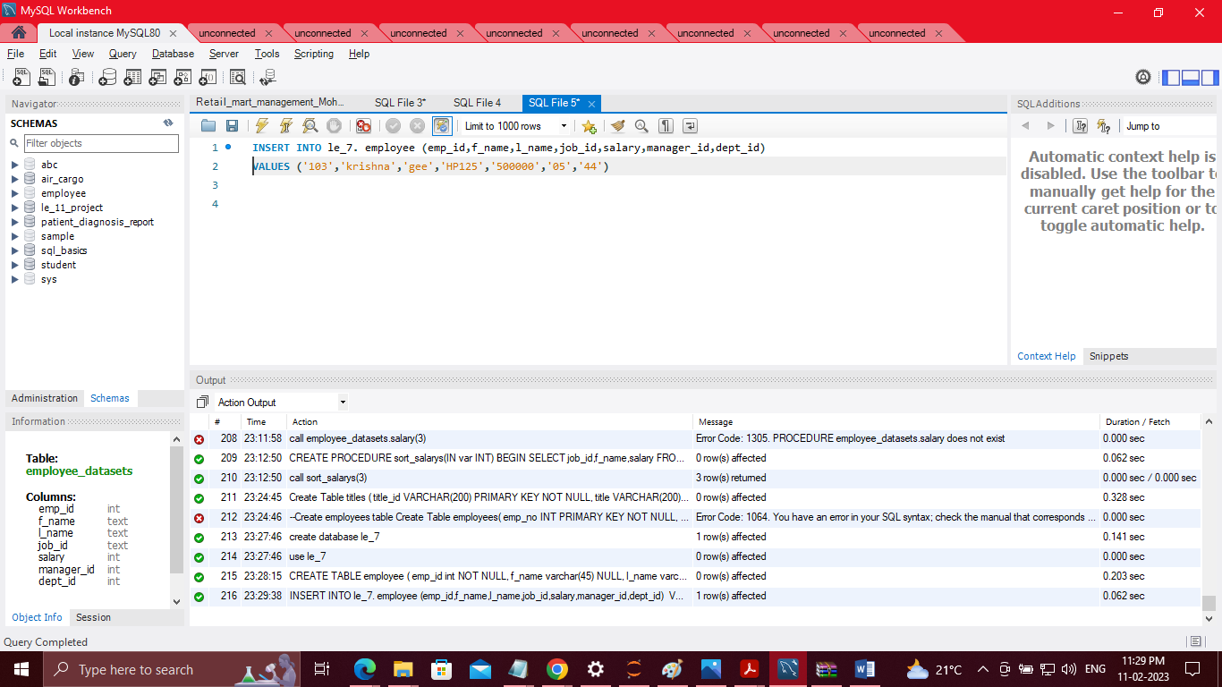

3, Write a query to find the first and last names of every employee whose salary is higher than the employee with the last name Kumar